**DAILY ONLINE ACTIVITIES SUMMARY**

|  |  |  |  |  |  |  |  |  |
| --- | --- | --- | --- | --- | --- | --- | --- | --- |
| **Date:** | **19/06/2020** | | | | | **Name:** | **POOJA D S** | |
| **Sem & Sec** | **4th Sem 'B' Section** | | | | | **USN:** | **4AL18CS056** | |
| **Online Test Summary** | | | | | | | | |
| **Subject** | | **Microcontroller Analysis of Algorithms** | | | | | | |
| **Max. Marks** | | **20** | | **Score** | | | **18** | |
| **Certification Course Summary** | | | | | | | | |
| **Course** | **Blockchain Basics** | | | | | | | |
| **Certificate Provider** | | | **Great Learning Academy** | | **Duration** | | | **2.5 hour** |
| **Coding Challenges** | | | | | | | | |
| **Problem Statement:** A user will input two strings, and we find if one of the strings is a sub sequence of the other. Program prints “yes” if either the first string is a sub sequence of the second string or the second string is a sub sequence of the first string. Assume that, the length of the first string is smaller than or equal to the length of the second string. Assume that, the length of the first string is smaller than or equal to the length of the second string. | | | | | | | | |
| **Status: completed** | | | | | | | | |
| **Uploaded the report in Github** | | | | | **yes** | | | |
| **If yes Repository name** | | | | | <https://github.com/dspooja/C-coding> | | | |
| **Uploaded the report in slack** | | | | | **yes** | | | |

Online Test Details: (Attach the snapshot and briefly write the report for the same)

Certification Course Details: (Attach the snapshot and briefly write the report for the same)

Coding Challenges Details: (Attach the snapshot and briefly write the report for the same)

ONLINE TEST DETAILS:

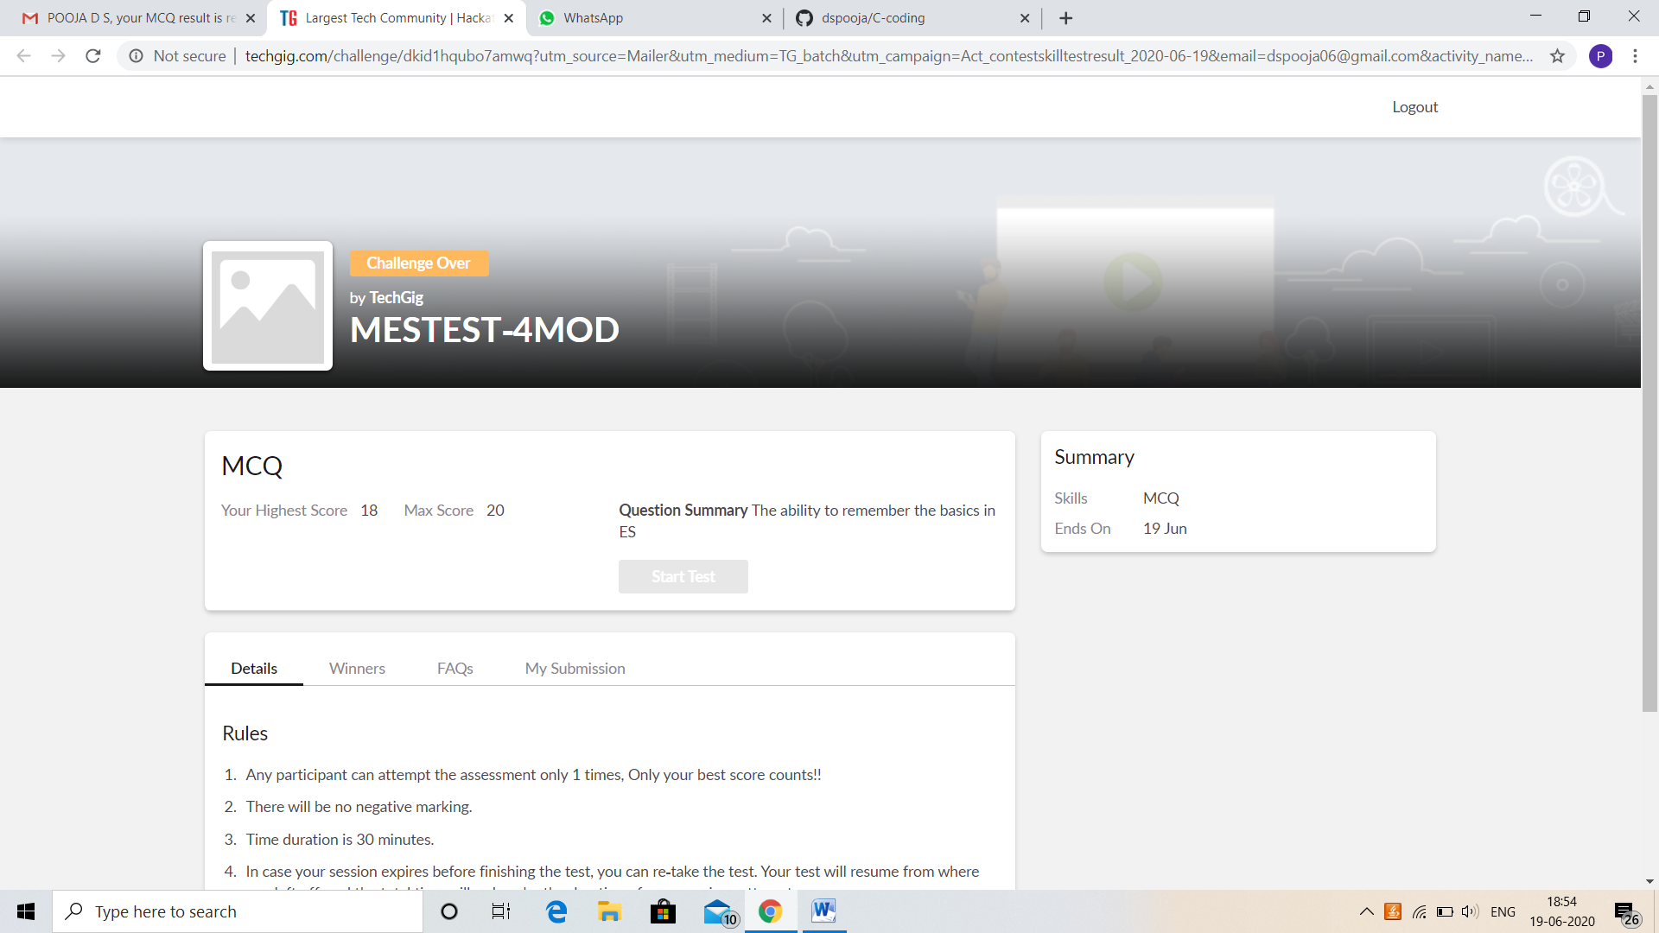

CERTIFICATION COURSE DETAILS:

* My Certification Course is Blockchain Basics.
* **The concepts covered in Blockchain Basics are:**
* Industry Challenges For Blockchain Adoption
* Blockchain Examples

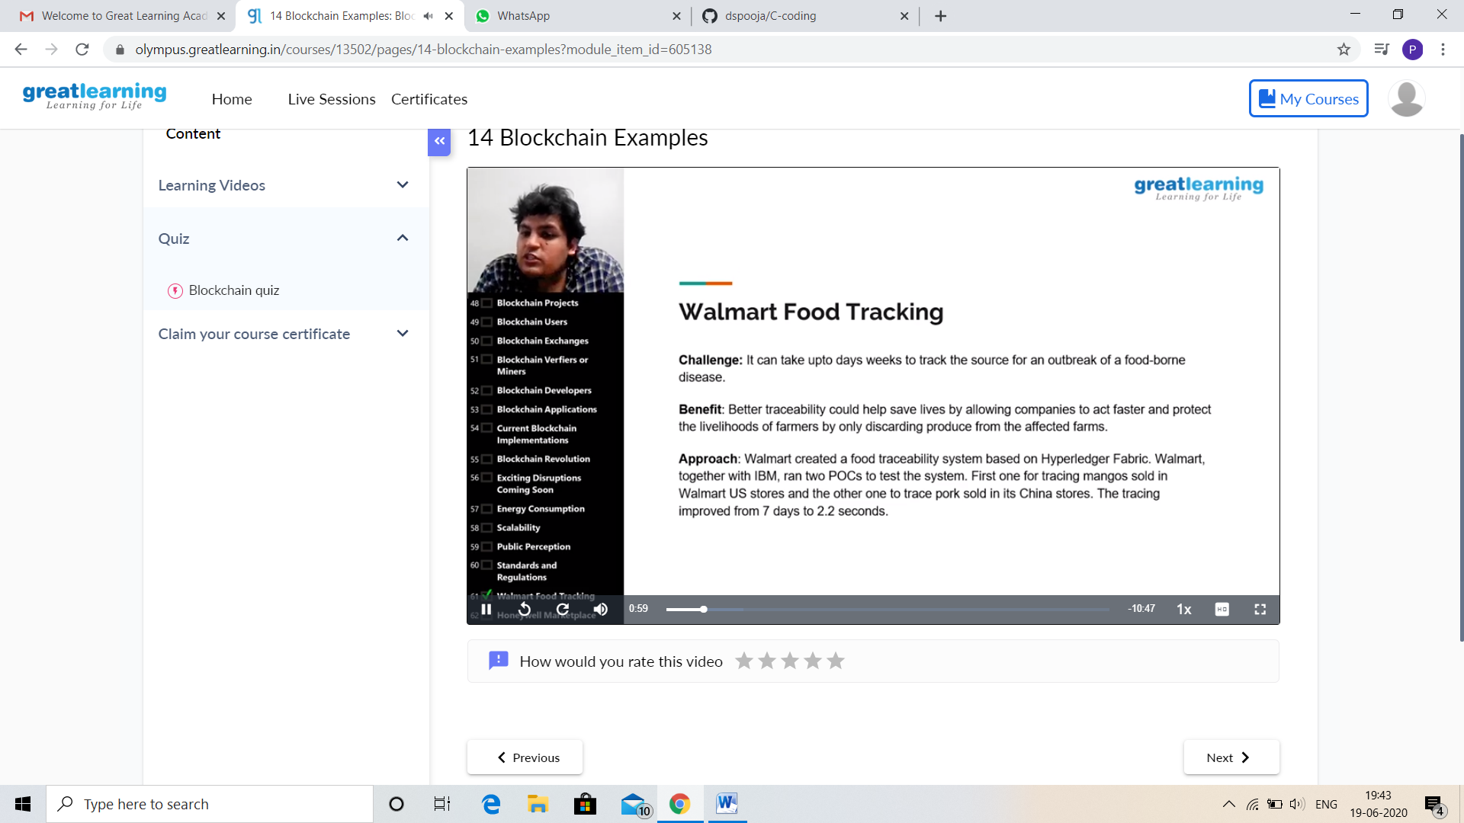

And I attend Quiz. I got good Experience. And this is my certificate

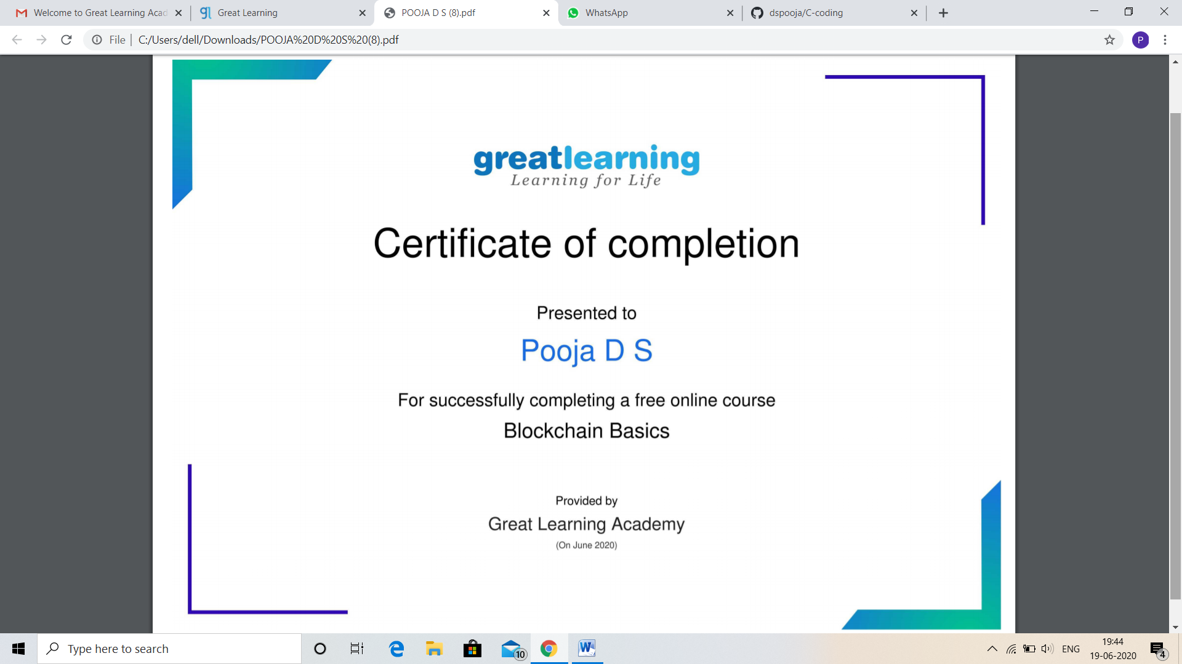

CODING CHALLENGES DETAILS:

Problem statement 1:

Write a C Program to Count total set bits in all numbers from 1 to n.

Given a positive integer n, count the total number of set bits in binary representation of all numbers from 1 to n.

**Examples:**  
Input: n = 3  
Output: 4  
Input: n = 6  
Output: 9

Solution: Uploaded in github.

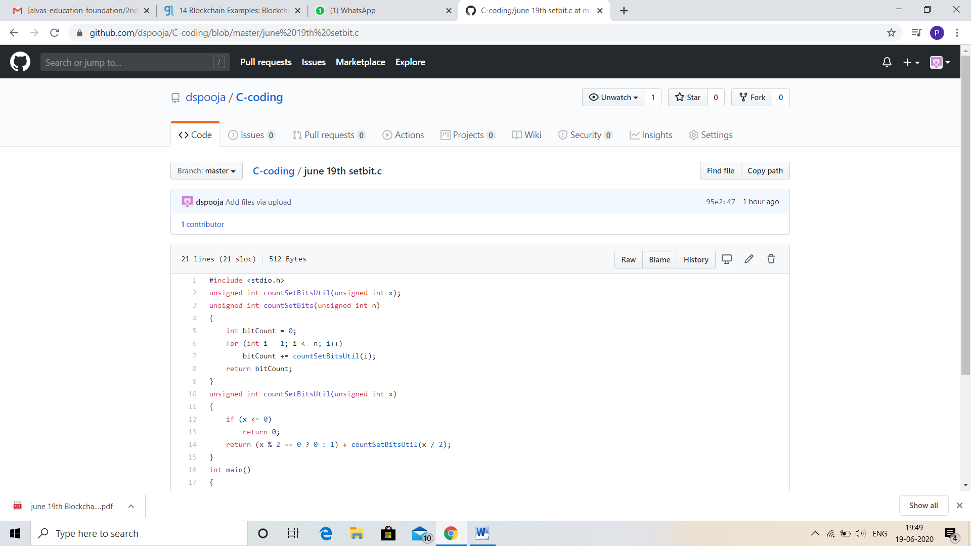

Problem statement 2:

Write a C Program to rotate a Matrix by 90 Degree in Clockwise or Anticlockwise Direction.

Matrix Rotation by 90 Degree in Clockwise Direction:

Input:  
Enter the total Number of Rows m: 3  
Enter the total Number of Columns: 3  
Enter the Elements of the Matrix:  
1 2 3 4 5 6 7 8 9  
Output:  
The Given Matrix is:  
1 2 3  
4 5 6  
7 8 9  
The Output Matrix After Rotation by 90 Degree in Clockwise Direction is:  
7 4 1  
8 5 2  
9 6 3

Matrix Rotation by 90 Degree in Anticlockwise Direction:

Input:  
Enter the total Number of Rows m: 3  
Enter the total Number of Columns: 3  
Enter the Elements of the Matrix:  
1 2 3 4 5 6 7 8 9  
Output:  
The Given Matrix is:  
1 2 3  
4 5 6  
7 8 9

The Output Matrix After Rotation by 90 Degree in Clockwise Direction is:  
3 6 9  
2 5 8  
1 4 7

Hint:  
Steps involved in Matrix Rotation by 90 Degree in Clockwise direction:  
⎝ Find the Transpose of the Matrix  
⎝ Reverse every rows of the Matrix

Steps involved in Matrix Rotation by 90 Degree in Anti clockwise direction:  
⎝ Find the Transpose of the Matrix  
⎝ Reverse every columns of the Matrix

Solution: Uploaded in github.

